4.14: a) With 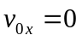,
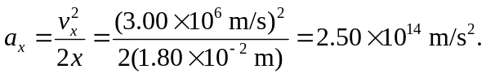
b) 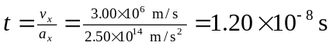. Note that this time is also the distance divided by the average speed.
c)

